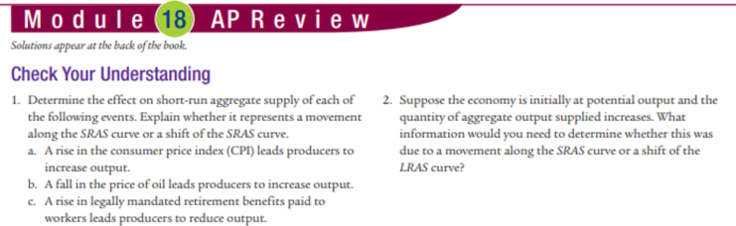

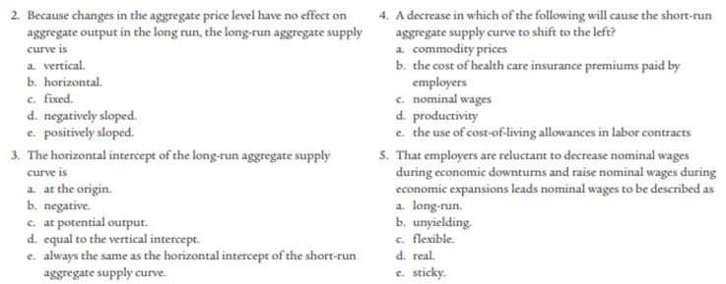

Check your understanding:
1. a movement along SRAS. B. shift of SRAS to right. C. shift of SRAS to left.
2. if price goes up, movement along SRAS if price goes down increase of LRAS
MC 1.e 2.a 3.c 4.d 5.e FR: 2.a. Y axis: Aggregate Price Level. X axis: Real GDP. SRAS b. SRAS shifts left.
FR Question 1:
